📊 Customer Shopping Behaviour Analysis

Customer Dataset Summary → Business Problem Identification → Python-Based Data Preprocessing → SQL Business Insights Analysis → Interactive Power BI Dashboard→ Solution to the Business Problem

📂 Dataset Summary
- Dataset Size: 3,900 records × 18 features.
- Purpose: Analyze customer behaviour, purchasing patterns, and business performance.
- Key Features: Customer demographics (Age, Gender, Location, Subscription Status), purchase details (Category, Item Purchased, Purchase Amount, Season, Size, Colour), and shopping behavior (Discount Applied, Promo Code Used, Previous Purchases, Purchase Frequency, Review Rating, Shipping Type).
- Data Quality: 37 missing values were identified in the Review Rating column and handled during data pre processing using Python (Pandas) in Jupyter Notebook. The cleaned dataset was then used for SQL analysis and Power BI dashboard development.

🎯 Business Problem
Retail businesses collect a large amount of customer transaction and purchasing data every day. However, this data is often stored in raw tables, making it difficult for business managers to identify customer purchasing patterns, monitor sales performance, evaluate subscription effectiveness, and understand which customer segments contribute the most to revenue.
Without proper data visualization and analysis, businesses face several challenges:
- Inability to identify high-value customer segments.
- Difficulty tracking overall revenue and sales performance.
- Limited understanding of subscription impact on customer purchases.
- Poor visibility into category-wise sales and revenue.
- Lack of insights into customer age groups and buying behaviour.
- Time-consuming manual reporting, leading to slower business decisions.

To address the identified business challenges, an end-to-end data analytics solution was developed by integrating Jupyter Notebook (Python), SQL, Power BI, and 🤖 AI-powered assistants throughout the analytics workflow.

🐍 Exploratory Data Analysis (EDA) Using Python
Exploratory Data Analysis (EDA) was performed using Jupyter Notebook with Python (Pandas & NumPy) to clean, preprocess, and prepare the dataset for SQL analysis and Power BI visualization. 🤖 Claude AI was used to optimize Python code and improve the data preparation workflow.
- Data Loading: Imported the dataset using Pandas.
- Initial Exploration: Examined data structure (df.info()), summary statistics (df.describe()), and data quality.
- Data Cleaning: Identified missing values and imputed 37 missing entries in the Review Rating column using the median rating for each product category.
- Data Transformation: Renamed columns to snake_case, created age_group and purchase_frequency_days features, and removed the redundant promo_code_used column.
- Database Integration: Loaded the cleaned dataset into PostgreSQL using SQLAlchemy for SQL-based business analysis.
- Outcome: Produced a clean, consistent, and analysis-ready dataset for advanced analytics and interactive Power BI dashboard development.

🗄️ Data Analysis Using SQL (PostgreSQL)
Business analysis was performed in PostgreSQL to extract actionable insights from the cleaned dataset. 💬 ChatGPT was used to assist in writing, optimizing, and validating SQL queries for efficient analysis.
The following business questions were addressed:
- Revenue by Gender: Compared total revenue generated by male and female customers.
- High-Spending Discount Users: Identified customers who used discounts while spending above the average purchase amount.
- Top-Rated Products: Ranked the top five products based on average customer review ratings.
- Shipping Type Analysis: Compared average purchase amounts across different shipping methods.
- Subscription Performance: Analyzed average spending and total revenue of subscribers versus non-subscribers.
- Discount Analysis: Identified products with the highest percentage of discounted purchases.
- Customer Segmentation: Categorized customers into New, Returning, and Loyal based on purchase history.
- Top Products by Category: Determined the three most purchased products within each product category.
- Repeat Purchase Analysis: Examined the relationship between repeat purchases and subscription status.
- Revenue by Age Group: Evaluated the revenue contribution of different customer age groups.
Outcome: The SQL analysis transformed transactional data into meaningful business insights, providing the foundation for interactive Power BI dashboards and data-driven decision-making.

📈 Power BI Dashboard Development

Built an interactive Power BI Customer Behavior Dashboard using Microsoft Copilot for DAX and development support.

📋 Dashboard Highlights
- KPI Cards: Total Customers, Total Revenue, Total Orders, Average Purchase Amount, Average Review Rating, and Average Items per Order.
- Revenue by Gender: Compares revenue generated by male and female customers.
- Revenue by Age Group: Identifies the highest revenue-contributing customer segments.
- Revenue by Product Category: Highlights the best-performing product categories.
- Subscription Analysis: Compares subscribers and non-subscribers based on spending and customer count.
- Customer Distribution: Visualizes customer demographics and purchasing behavior.
- Interactive Slicers: Filter data by Date, Gender, Category, Subscription Status, and Shipping Type.
- Custom DAX Measures: Developed dynamic calculations for KPIs and business metrics.
- Interactive Dashboard: Cross-filtering and drill-down capabilities enable detailed analysis.
- Outcome: Provides a centralized Business Intelligence dashboard that supports faster, data-driven decision-making through clear and interactive visualizations.
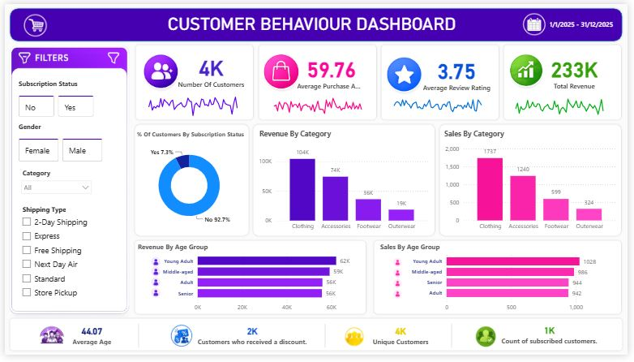

💡 Solution to the Business Problem
To solve these challenges, an interactive Customer Behavior Dashboard was developed using Power BI. The dashboard provides the following solutions:
- Displays key business KPIs such as Total Customers, Total Revenue, Average Purchase Amount, Average Review Rating, Total Orders, and Average Items per Order.
- Compares subscription vs. non-subscription customers to evaluate the effectiveness of the subscription program.
- Analyzes revenue and sales by product category to identify the best-performing product lines.
- Evaluates customer purchasing behavior across different age groups to determine the most valuable customer segments.
- Enables interactive filtering by Subscription Status, Gender, Product Category, Shipping Type, and Date Range for detailed analysis.
- Highlights top-performing customer groups, helping management focus marketing efforts on high-value customers.
- Provides a centralized dashboard that replaces manual reporting and supports faster, data-driven decision-making.

